Year 9 Curriculum Explained
The curriculum teaches the fundamental ideas which are the building blocks of artistic understanding, and we sequence these in the best order so that students can see how these fundamental ideas link together.
Our Art curriculum intends to train excellent artists. This means that they will be able to:
- Select appropriate drawing media.
- Select appropriate painting media.
- Understand and apply tone.
- Mix a variety of colours.
- Understand colour theory.
- Express opinions confidently using correct artistic language.
- Identify and apply the formal elements of art and design.
- Select appropriate information on cultural and historical events.
- Transfer and construct a 2D design into 3D.
- Understand and show an awareness of health and safety in a practical subject.
- Produce a series of 2D and 3D outcomes.

Year 9 SOW
Project 1  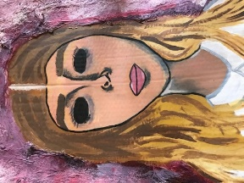 | Portraits and Society  Pupils will explore the theme of portraits.  reference to the work of Modigliani  They will develop ideas and imagery in a wide range of drawing and painting media and techniques, and produce a final painting in response to the theme.  Test One- What are the formal elements?  Q:\Art\1 Art Schemes and Resources\KS3\Yr9\Year 9 SOW and assessment 2019\Knowledge organiser for booklet
Project 2  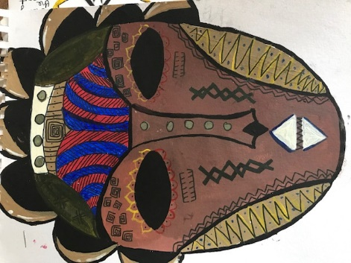 | African Masks  Pupils will investigate the geography and artistic designs of masks from across Africa.  They will record, develop ideas and imagery using 3D techniques to produce a final sculpture in response to the theme.  Test Two- Media techniques explained – wet media.  Q:\Art\1 Art Schemes and Resources\KS3\Yr9\Year 9 SOW and assessment 2019\Knowledge organiser for booklet
Project 3  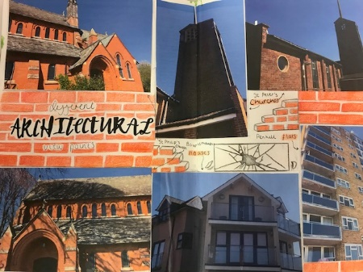 | Architecture and Viewpoints  Pupils will explore the theme of ‘Myself’ with reference to ‘Pop Art’ and other Art & Design sources from popular culture.  They will develop ideas and imagery in a wide range of media and techniques, and produce a painting or mixed media response to the theme.  Test Three- Media techniques explained – Dry media.  Q:\Art\1 Art Schemes and Resources\KS3\Yr9\Year 9 SOW and assessment 2019\Knowledge organiser for booklet

