Year 8 Curriculum Explained

The curriculum teaches the fundamental philosophies which are the building blocks of artistic understanding, and we sequence these in the best order so that students can see how these fundamental ideas link together.

Our Art curriculum intends to train excellent artists. This means that they will be able to independently:
- Select appropriate drawing media
- Use mathematical equipment
- Prior knowledge of mathematical terminology
- Produce a series of printed outcomes
- Select appropriate painting media
- Understand and apply painting techniques
- Select appropriate research information for art history and cultural studies
- Use textiles materials and techniques
- Understand and show an awareness of health and safety in a practical subject
- Produce an art textiles outcome
- Utilise colour theory
- Understand and employ one point perspective in landscape composition

Year 8 SOW
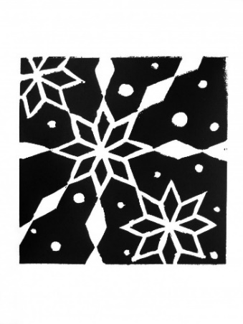 | Pattern in Non Western Art – Islamic Art  Pupils will explore the visual decoration of Islamic Art. In particular they will look at Islamic tiles and screens. They will develop their ideas and observations using a variety of different media and techniques. They will produce a final series of lino prints in response to the theme.  Q:\Art\1 Art Schemes and Resources\KS3\Yr8\Year 8 SOW and Assessment\Knowledge Organisers
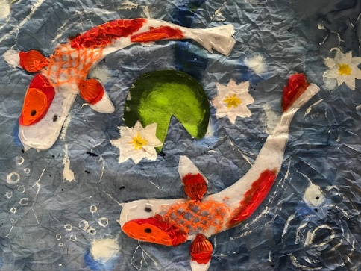 | Colour and shape in Japanese Art  Pupils will make a series of studies from Japanese art This will serve as the springboard to introduce the medium of textiles in Art. They will develop ideas and imagery using textile techniques such as batik and tie dye and produce a final outcome in response to the theme. (Painting, mark making, sewing and batik).  Q:\Art\1 Art Schemes and Resources\KS3\Yr8\Year 8 SOW and Assessment\Knowledge Organisers
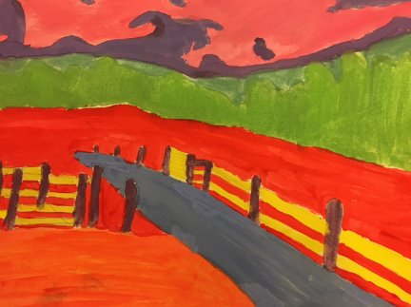 | British Landscape Painting  Pupils will explore the theme of British Landscape painting with reference to David Hockney. They will develop ideas and imagery in a wide range of 2D media and techniques, and produce a painted response to the theme.  Q:\Art\1 Art Schemes and Resources\KS3\Yr8\Year 8 SOW and Assessment\Knowledge Organisers

