Year 7 Curriculum Explained

The curriculum teaches the fundamental philosophies which are the building blocks of artistic understanding, and we sequence these in the best order so that students can see how these fundamental ideas link together.

Our Art curriculum intends to train excellent artists. This means that they will be able to independently:
- Select appropriate drawing media.
- Select appropriate painting media.
- Understand and apply tone.
- Mix a variety of colours.
- Understand colour theory.
- Express opinions confidently using correct artistic language.
- Identify and apply the formal elements of art and design.
- Select appropriate information on cultural and historical events.
- Transfer and construct a 2D design into 3D.
- Understand and show an awareness of health and safety in a practical subject.
- Produce a series of painted and printed outcomes.

Year 7 SOW
Project 1  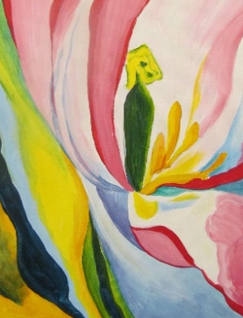 | Still Life and Natural Form.  Pupils will explore the theme of ‘natural form’  (Skulls, Flowers etc with reference to the work of Georgia O’keeffe.  They will develop ideas and imagery in a wide range of drawing and painting media and techniques, and produce a final painting in response to the theme.  Topic A & B Knowledge Organiser -  Q:\Art\1 Art Schemes and Resources\KS3\Yr7\YEAR 7 SOW AND ASSESSMENT\Knowledge Organisers
Project 2  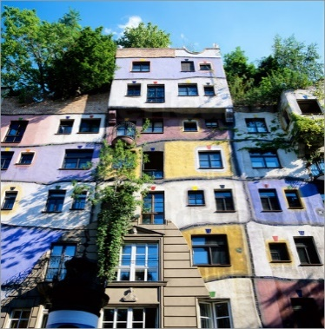 | Famous Buildings around the world.  Pupils will investigate and record a series of famous building s around the world.  This will serve as the bridge to introduce the architecture of Hundertwasser.  They will develop ideas and imagery using 3D techniques to produce a final sculpture in response to the theme.  Topic A & B Knowledge Organiser -  Q:\Art\1 Art Schemes and Resources\KS3\Yr7\YEAR 7 SOW AND ASSESSMENT\Knowledge Organisers
Project 3  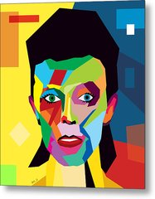 | Myself  Pupils will explore the theme of ‘Myself’ with reference to ‘Pop Art’ and other Art & Design sources from popular culture.  They will develop ideas and imagery in a wide range of media and techniques, and produce a painting or mixed media response to the theme.  Topic A & B Knowledge Organiser –  Q:\Art\1 Art Schemes and Resources\KS3\Yr7\YEAR 7 SOW AND ASSESSMENT\Knowledge Organisers

